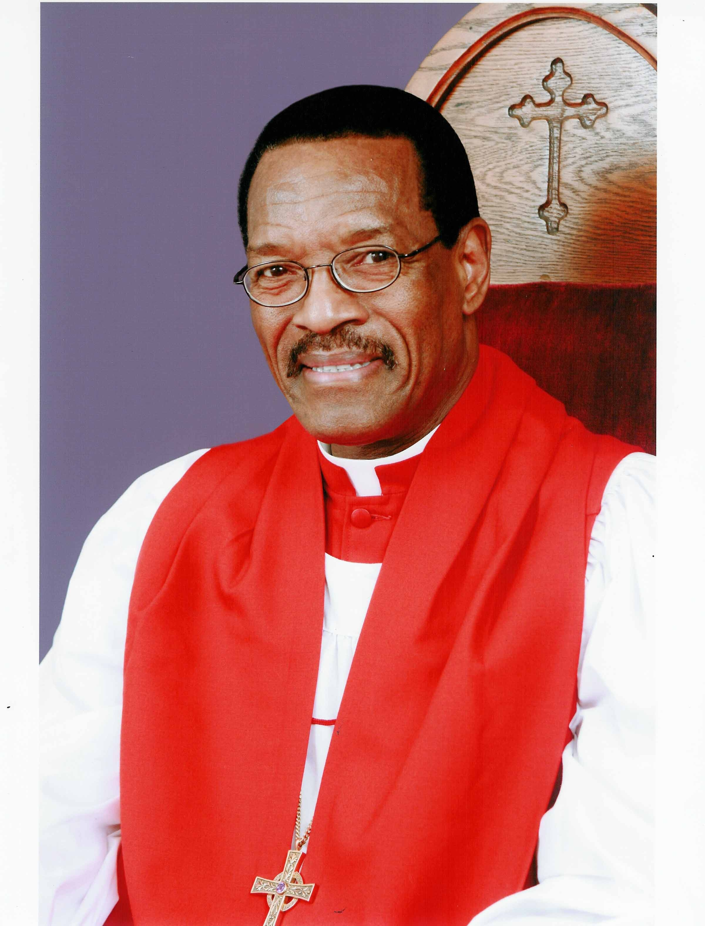
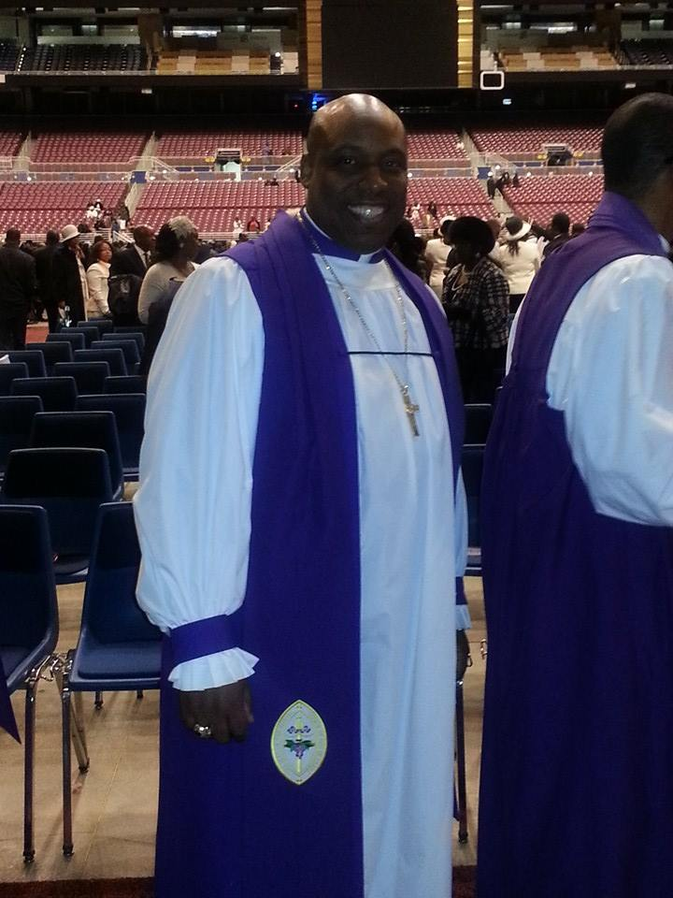
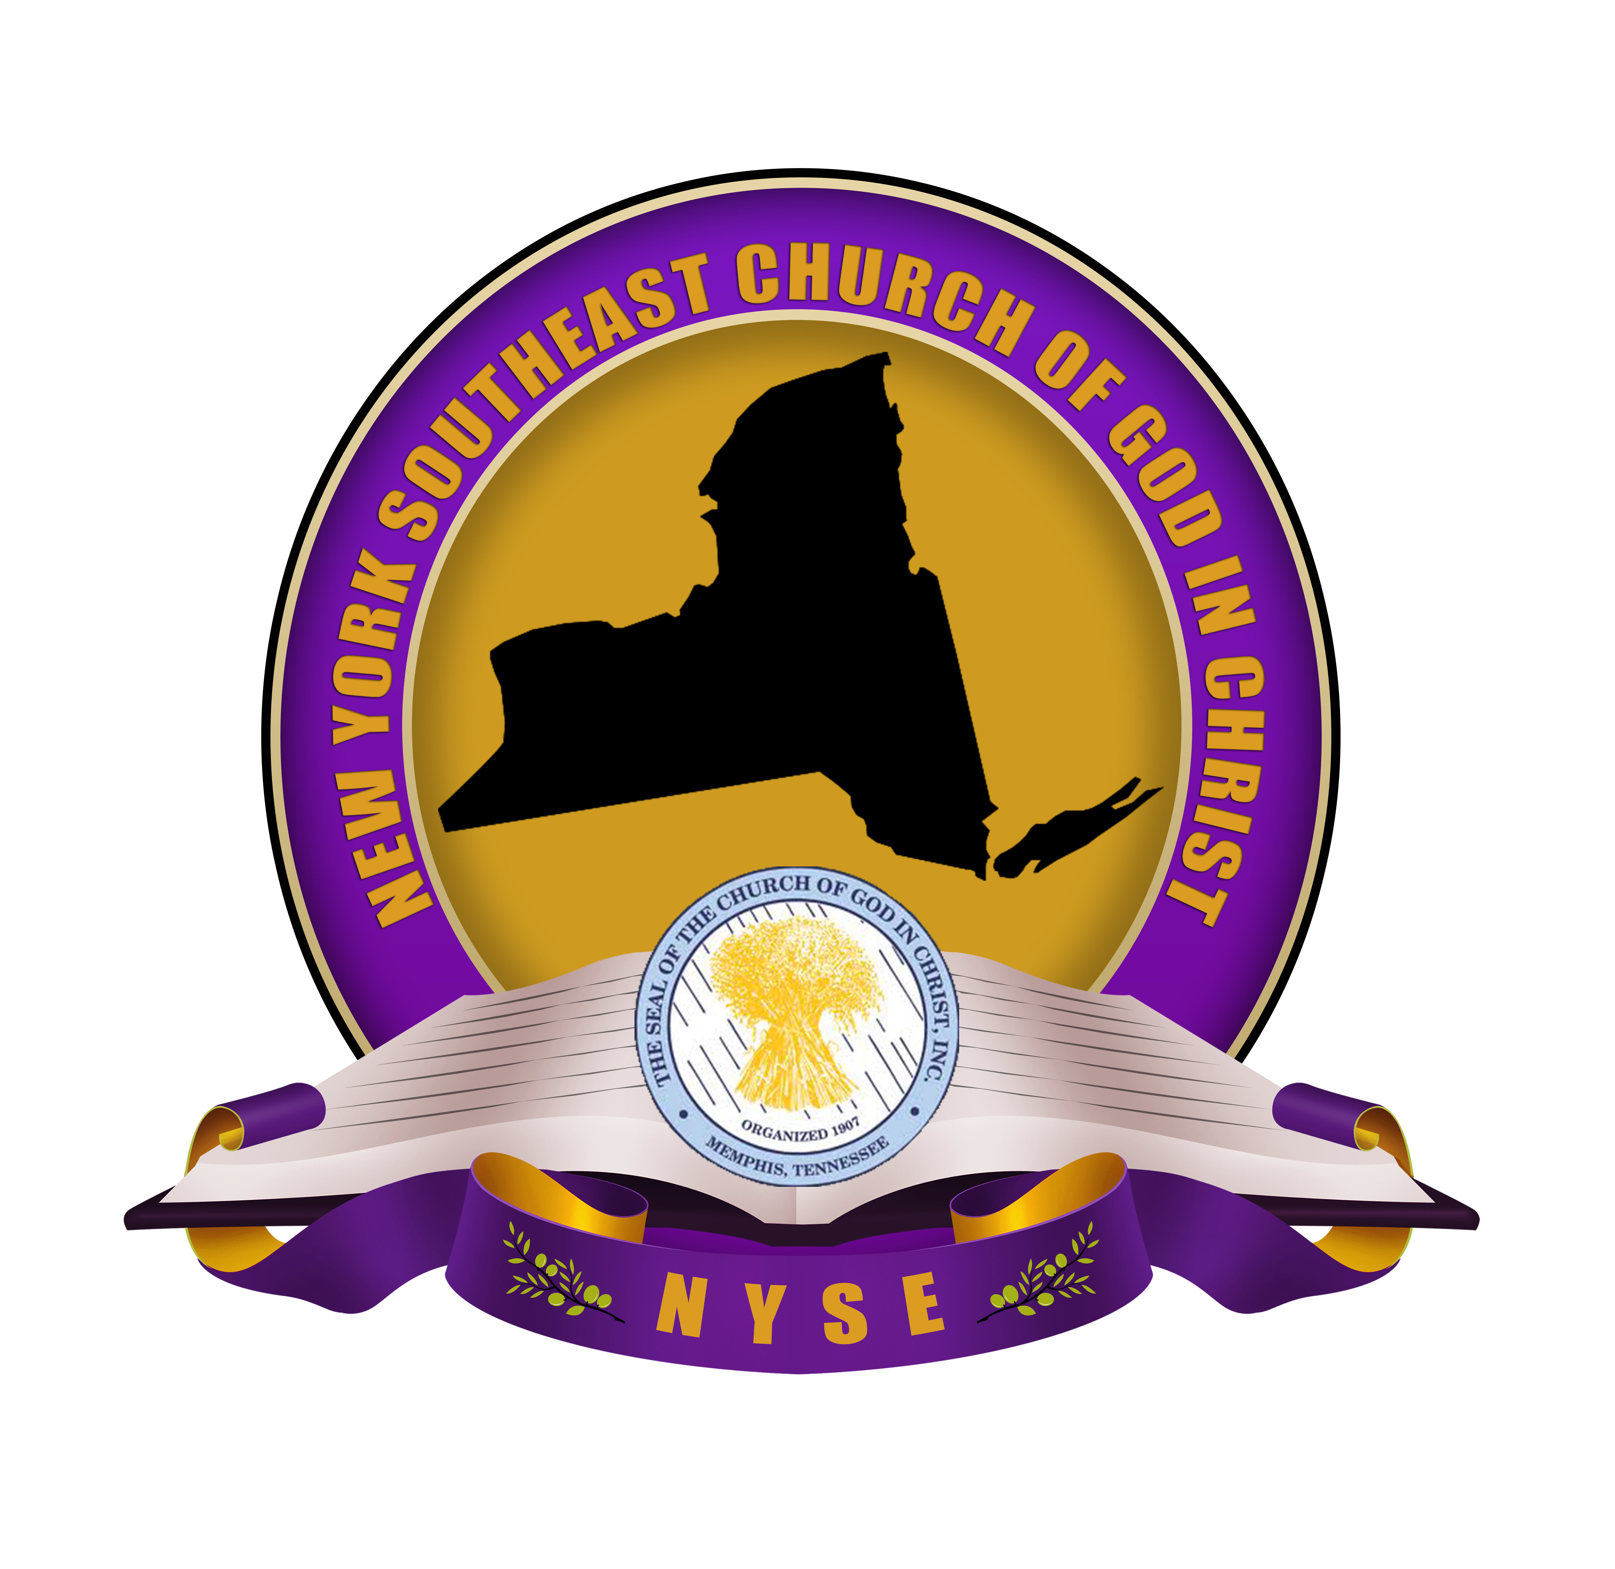
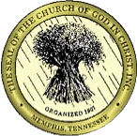
January
Jurisdictional Headquarters
Salvation & Restoration Christian COGIC
1142 Herkimer Street
Brooklyn, New York 11233
(718) 342-8434 ph * (718) 485-3169 fax
“Empowering, Equipping and Engaging Believers for Kingdom Ministry”
COME FELLOWSHIP WITH US AT ONE OF OUR MANY WORSHIP OPPORTUNITIES
Bishop Charles E. Blake
International Presiding Bishop

Bishop Tyrone L. Butler
Jurisdictional Prelate

2017
Sun | Mon | Tue | Wed | Thu | Fri | Sat
1 NEW YEAR’S DAY | 2 | 3 | 4 | 5 | 6 | 7 Jurisdiction Events - Jurisdictional Installation & Communion Service
8 | 9 | 10 | 11 | 12 | 13 | 14
15 | 16 MLK Birthday  COGIC Leadership Conf- Little Rock, AR | 17 COGIC Leadership Conf- Little Rock, AR | 18 COGIC Leadership Conf- Little Rock, AR | 19 COGIC Leadership Conf- Little Rock, AR | 20 | 21
22 | 23 | 24 | 25 | 26 | 27 | 28 NYSE Women’s Dept Set-up Meeting 10:00 a.m.
29 | 30 | 31

February
Sun | Mon | Tue | Wed | Thu | Fri | Sat
 |  |  | 1 | 2 | 3 | 4 Jurisdictional Events -Quarterly Empowerment Conference – 11:00 a.m.
5 | 6 | 7 | 8 | 9 | 10 | 11
12 | 13 NYSEJ Exec Board Bi-Monthly | 14 Valentines Day | 15 | 16 | 17 | 18
19 | 20 Presidents Day | 21 | 22 | 23 | 24 | 25
26 | 27 | 28

2017
Jurisdictional Headquarters
Salvation & Restoration Christian COGIC
1142 Herkimer Street
Brooklyn, New York 11233
(718) 342-8434 ph * (718) 485-3169 fax
“Empowering, Equipping and Engaging Believers for Kingdom Ministry”
COME FELLOWSHIP WITH US AT ONE OF OUR MANY WORSHIP OPPORTUNITIES
Bishop Charles E. Blake
International Presiding Bishop

Bishop Tyrone L. Butler
Jurisdictional Prelate

March
Sun | Mon | Tue | Wed | Thu | Fri | Sat
 |  |  | 1 | 2 | 3 | 4 Jurisdictional Events - Evangelism Conference
5 | 6 | 7 | 8 | 9 | 10 | 11
12 | 13 | 14 | 15 | 16 | 17 | 18
19 | 20 | 21 | 22 | 23 | 24 | 25
26 | 27 DISTRICT MEETINGS-Mid Hudson, Supt. Stukes | 28 DISTRICT MEETINGS-Mid Hudson | 29 DISTRICT MEETINGS-Mid Hudson | 30 DISTRICT MEETINGS-Mid Hudson | 31 DISTRICT MEETINGS-Mid Hudson

2017
Jurisdictional Headquarters
Salvation & Restoration Christian COGIC
1142 Herkimer Street
Brooklyn, New York 11233
(718) 342-8434 ph * (718) 485-3169 fax
“Empowering, Equipping and Engaging Believers for Kingdom Ministry”
COME FELLOWSHIP WITH US AT ONE OF OUR MANY WORSHIP OPPORTUNITIES
Bishop Charles E. Blake
International Presiding Bishop

Bishop Tyrone L. Butler
Jurisdictional Prelate

25th ANNUAL PASTORS & WORKERS CONFERENCE
Episcopal Headquarters - Brooklyn, New York

April
Sun | Mon | Tue | Wed | Thu | Fri | Sat
 |  |  |  |  |  | 1 Jurisdictional Events - Call Meeting and Assembly
2 | 3 COGIC Annual Spring Call Meeting-Memphis,TN | 4 COGIC Annual Spring Call Meeting | 5 COGIC Annual Spring Call Meeting | 6 COGIC Annual Spring Call Meeting | 7 | 8
9 | 10 NYSEJ Exec Board Bi-Monthly | 11 | 12 | 13 | 14 | 15
16 EASTER (Resurrection Sunday) | 17 | 18 | 19 | 20 | 21 | 22
23 | 24 | 25 | 26 DISTRICT MEETINGS-Acts 2:42, Supt. Hutton | 27 DISTRICT MEETINGS-Acts 2:42, | 28 DISTRICT MEETINGS-Acts 2:42, | 29
30

2017
Jurisdictional Headquarters
Salvation & Restoration Christian COGIC
1142 Herkimer Street
Brooklyn, New York 11233
(718) 342-8434 ph * (718) 485-3169 fax
“Empowering, Equipping and Engaging Believers for Kingdom Ministry”
COME FELLOWSHIP WITH US AT ONE OF OUR MANY WORSHIP OPPORTUNITIES
Bishop Charles E. Blake
International Presiding Bishop

Bishop Tyrone L. Butler
Jurisdictional Prelate

May
Sun | Mon | Tue | Wed | Thu | Fri | Sat
 | 1 | 2 | 3 | 4 | 5 | 6 Jurisdictional Events - Bible School Graduation
7 | 8 | 9 | 10 | 11 | 12 | 13
14 Mothers Day | 15 | 16 | 17 DISTRICT MEETINGS-Manhattan, Supt. Pressley | 18 DISTRICT MEETINGS-Manhattan, | 19 DISTRICT MEETINGS-Manhattan, | 20
21 | 22 | 23 | 24 | 25 | 26 | 27
28 | 29 Memorial Day 67th Annual Women’s Convention-Orlando, FL | 30 67th Annual Women’s Convention-Orlando, FL | 31 67th Annual Women’s Convention-Orlando, FL

2017
Jurisdictional Headquarters
Salvation & Restoration Christian COGIC
1142 Herkimer Street
Brooklyn, New York 11233
(718) 342-8434 ph * (718) 485-3169 fax
“Empowering, Equipping and Engaging Believers for Kingdom Ministry”
COME FELLOWSHIP WITH US AT ONE OF OUR MANY WORSHIP OPPORTUNITIES
Bishop Charles E. Blake
International Presiding Bishop

Bishop Tyrone L. Butler
Jurisdictional Prelate

June
Sun | Mon | Tue | Wed | Thu | Fri | Sat
 |  |  |  | 1 67th Annual Women’s Convention-Orlando, FL | 2 67th Annual Women’s Convention-Orlando, FL | 3 Jurisdictional Events - Quarterly Empowerment Conference
4 PENTECOST SUNDAY | 5 | 6 | 7 | 8 | 9 | 10
11 | 12 NYSEJ Exec Board Bi-Monthly | 13 | 14 | 15 | 16 | 17
18 Fathers Day | 19 DISTRICT MEETINGS-Liberty, Supt. Griffin | 20 DISTRICT MEETINGS-Liberty | 21 DISTRICT MEETINGS-Liberty | 22 DISTRICT MEETINGS-Liberty | 23 DISTRICT MEETINGS-Liberty | 24
25 | 26 | 27 | 28 | 29 | 30

2017
Jurisdictional Headquarters
Salvation & Restoration Christian COGIC
1142 Herkimer Street
Brooklyn, New York 11233
(718) 342-8434 ph * (718) 485-3169 fax
“Empowering, Equipping and Engaging Believers for Kingdom Ministry”
COME FELLOWSHIP WITH US AT ONE OF OUR MANY WORSHIP OPPORTUNITIES
Bishop Charles E. Blake
International Presiding Bishop

Bishop Tyrone L. Butler
Jurisdictional Prelate

New York Southeast
A.I.M. (Auxiliaries In Ministry) CONFERENCE
June 14 - 17
Salvation and Restoration COGIC, Brooklyn

July
Sun | Mon | Tue | Wed | Thu | Fri | Sat
 |  |  |  |  |  | 1 Jurisdictional Events - CANCELLED
2 | 3 International AIM Convention-Charlotte, NC | 4 Independence Day | 5 International AIM Convention-Charlotte, NC | 6 International AIM Convention-Charlotte, NC | 7 International AIM Convention-Charlotte, NC | 8
9 | 10 | 11 | 12 | 13 | 14 | 15
16 | 17 | 18 | 19 | 20 | 21 | 22 NYSE Picnic Day @ Lakes State Park – 11:00 a.m
23 | 24 | 25 | 26 | 27 | 28 | 29
30 | 31

2017
Jurisdictional Headquarters
Salvation & Restoration Christian COGIC
1142 Herkimer Street
Brooklyn, New York 11233
(718) 342-8434 ph * (718) 485-3169 fax
“Empowering, Equipping and Engaging Believers for Kingdom Ministry”
COME FELLOWSHIP WITH US AT ONE OF OUR MANY WORSHIP OPPORTUNITIES
Bishop Charles E. Blake
International Presiding Bishop

Bishop Tyrone L. Butler
Jurisdictional Prelate

August
Sun | Mon | Tue | Wed | Thu | Fri | Sat
 |  | 1 | 2 | 3 | 4 | 5 Jurisdictional Events - Missions Impact Conference
6 | 7 NYSEJ Exec Board Bi-Monthly | 8 | 9 | 10 | 11 | 12
13 | 14 | 15 | 16 | 17 | 18 | 19
20 25th Annual Holy Convocation OFFICIAL DAY | 21 | 22 | 23 | 24 | 25 | 26
27 | 28 | 29 | 30 | 31

2017
Jurisdictional Headquarters
Salvation & Restoration Christian COGIC
1142 Herkimer Street
Brooklyn, New York 11233
(718) 342-8434 ph * (718) 485-3169 fax
“Empowering, Equipping and Engaging Believers for Kingdom Ministry”
COME FELLOWSHIP WITH US AT ONE OF OUR MANY WORSHIP OPPORTUNITIES
Bishop Charles E. Blake
International Presiding Bishop

Bishop Tyrone L. Butler
Jurisdictional Prelate

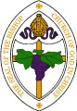
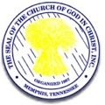
25th ANNUAL HOLY CONVOCATION
Brooklyn, New York

September
2017
Jurisdictional Headquarters
Salvation & Restoration Christian COGIC
1142 Herkimer Street
Brooklyn, New York 11233
(718) 342-8434 ph * (718) 485-3169 fax
“Empowering, Equipping and Engaging Believers for Kingdom Ministry”
COME FELLOWSHIP WITH US AT ONE OF OUR MANY WORSHIP OPPORTUNITIES
Bishop Charles E. Blake
International Presiding Bishop

Bishop Tyrone L. Butler
Jurisdictional Prelate

Sun | Mon | Tue | Wed | Thu | Fri | Sat
 |  |  |  |  | 1 | 2 Jurisdictional Events - Quarterly Empowerment Conference
3 | 4 Labor Day  Bishop Butler Birthday | 5 | 6 | 7 | 8 | 9
10 | 11 | 12 | 13 | 14 | 15 | 16 Service of Baptism
17 | 18 | 19 | 20 | 21 | 22 | 23
24 | 25 | 26 | 27 | 28 | 29 | 30

New York Southeast
23rd ANNUAL WOMEN’S CONVENTION
September 27 – 29, 2017

October
Sun | Mon | Tue | Wed | Thu | Fri | Sat
1 | 2 NYSEJ Exec Board Bi-Monthly | 3 | 4 | 5 | 6 | 7 Jurisdictional Events - Sunday School UniversityDay
8 | 9 Columbus Day | 10 | 11 | 12 | 13 | 14
15 | 16 | 17 | 18 | 19 | 20 | 21
22 | 23 | 24 | 25 | 26 | 27 | 28 NY Southeast Annual Judah Jam
29 | 30 | 31

2017
Jurisdictional Headquarters
Salvation & Restoration Christian COGIC
1142 Herkimer Street
Brooklyn, New York 11233
(718) 342-8434 ph * (718) 485-3169 fax
“Empowering, Equipping and Engaging Believers for Kingdom Ministry”
COME FELLOWSHIP WITH US AT ONE OF OUR MANY WORSHIP OPPORTUNITIES
Bishop Charles E. Blake
International Presiding Bishop

Bishop Tyrone L. Butler
Jurisdictional Prelate

November
2017
Jurisdictional Headquarters
Salvation & Restoration Christian COGIC
1142 Herkimer Street
Brooklyn, New York 11233
(718) 342-8434 ph * (718) 485-3169 fax
“Empowering, Equipping and Engaging Believers for Kingdom Ministry”
COME FELLOWSHIP WITH US AT ONE OF OUR MANY WORSHIP OPPORTUNITIES
Bishop Charles E. Blake
International Presiding Bishop

Bishop Tyrone L. Butler
Jurisdictional Prelate

Sun | Mon | Tue | Wed | Thu | Fri | Sat
 |  |  | 1 | 2 | 3 | 4 Jurisdictional Events - Unity Day and Rally
5 | 6 110TH Annual Holy Convocation-St Louis, MO | 7 110TH Annual Holy Convocation-St Louis, MO | 8 110TH Annual Holy Convocation-St Louis, MO | 9 110TH Annual Holy Convocation-St Louis, MO | 10 110TH Annual Holy Convocation-St Louis, MO | 11 Veterans Day
12 110TH Annual Holy Convocation-St Louis, MO OFFICIAL DAY | 13 | 14 | 15 | 16 | 17 | 18
19 | 20 | 21 | 22 | 23 Thanksgiving Day | 24 | 25
26 | 27 | 28 | 29 | 30

December
2017
Jurisdictional Headquarters
Salvation & Restoration Christian COGIC
1142 Herkimer Street
Brooklyn, New York 11233
(718) 342-8434 ph * (718) 485-3169 fax
“Empowering, Equipping and Engaging Believers for Kingdom Ministry”
COME FELLOWSHIP WITH US AT ONE OF OUR MANY WORSHIP OPPORTUNITIES
Bishop Charles E. Blake
International Presiding Bishop

Bishop Tyrone L. Butler
Jurisdictional Prelate

Sun | Mon | Tue | Wed | Thu | Fri | Sat
 |  |  |  |  | 1 Jurisdictional Events - Year End Retreat & Leaders Summit | 2 Jurisdictional Events - Year End Retreat & Leaders Summit
3 | 4 | 5 | 6 | 7 | 8 | 9
10 | 11 NYSEJ Exec Board Bi-Monthly | 12 | 13 | 14 | 15 | 16
17 | 18 | 19 | 20 | 21 | 22 | 23
24 | 25 Christmas Day | 26 | 27 | 28 | 29 | 30
31 New Year’s Eve
Watch Night

