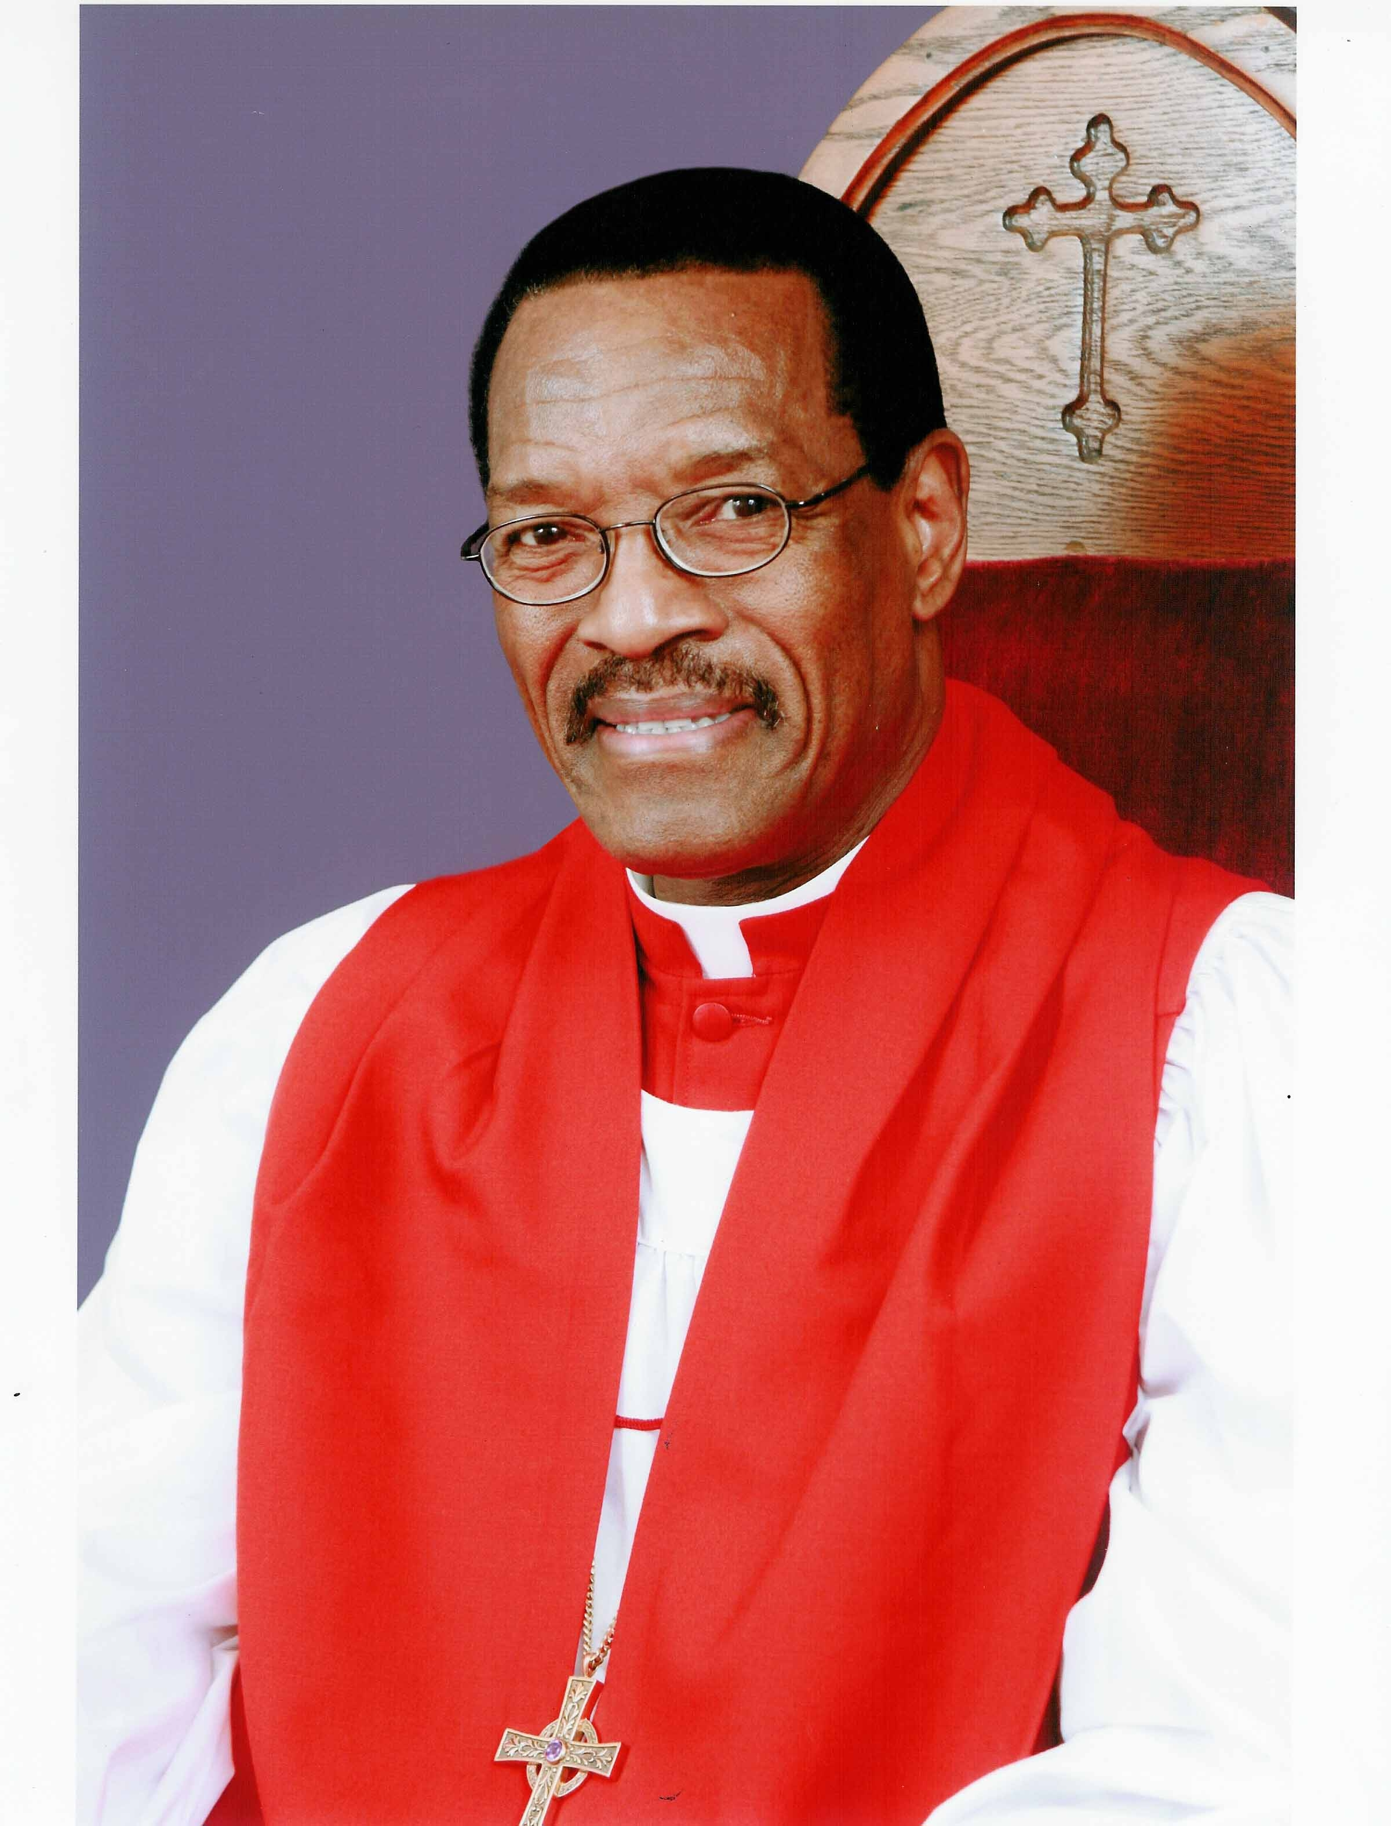
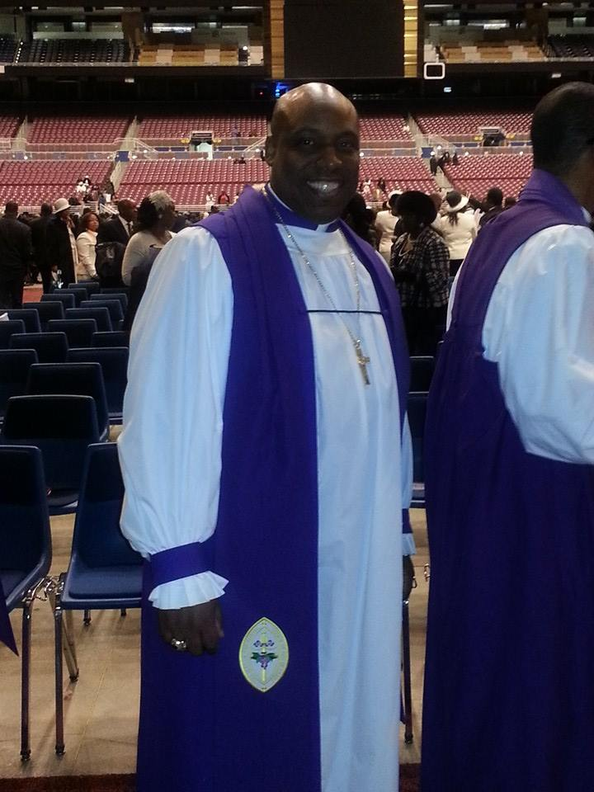
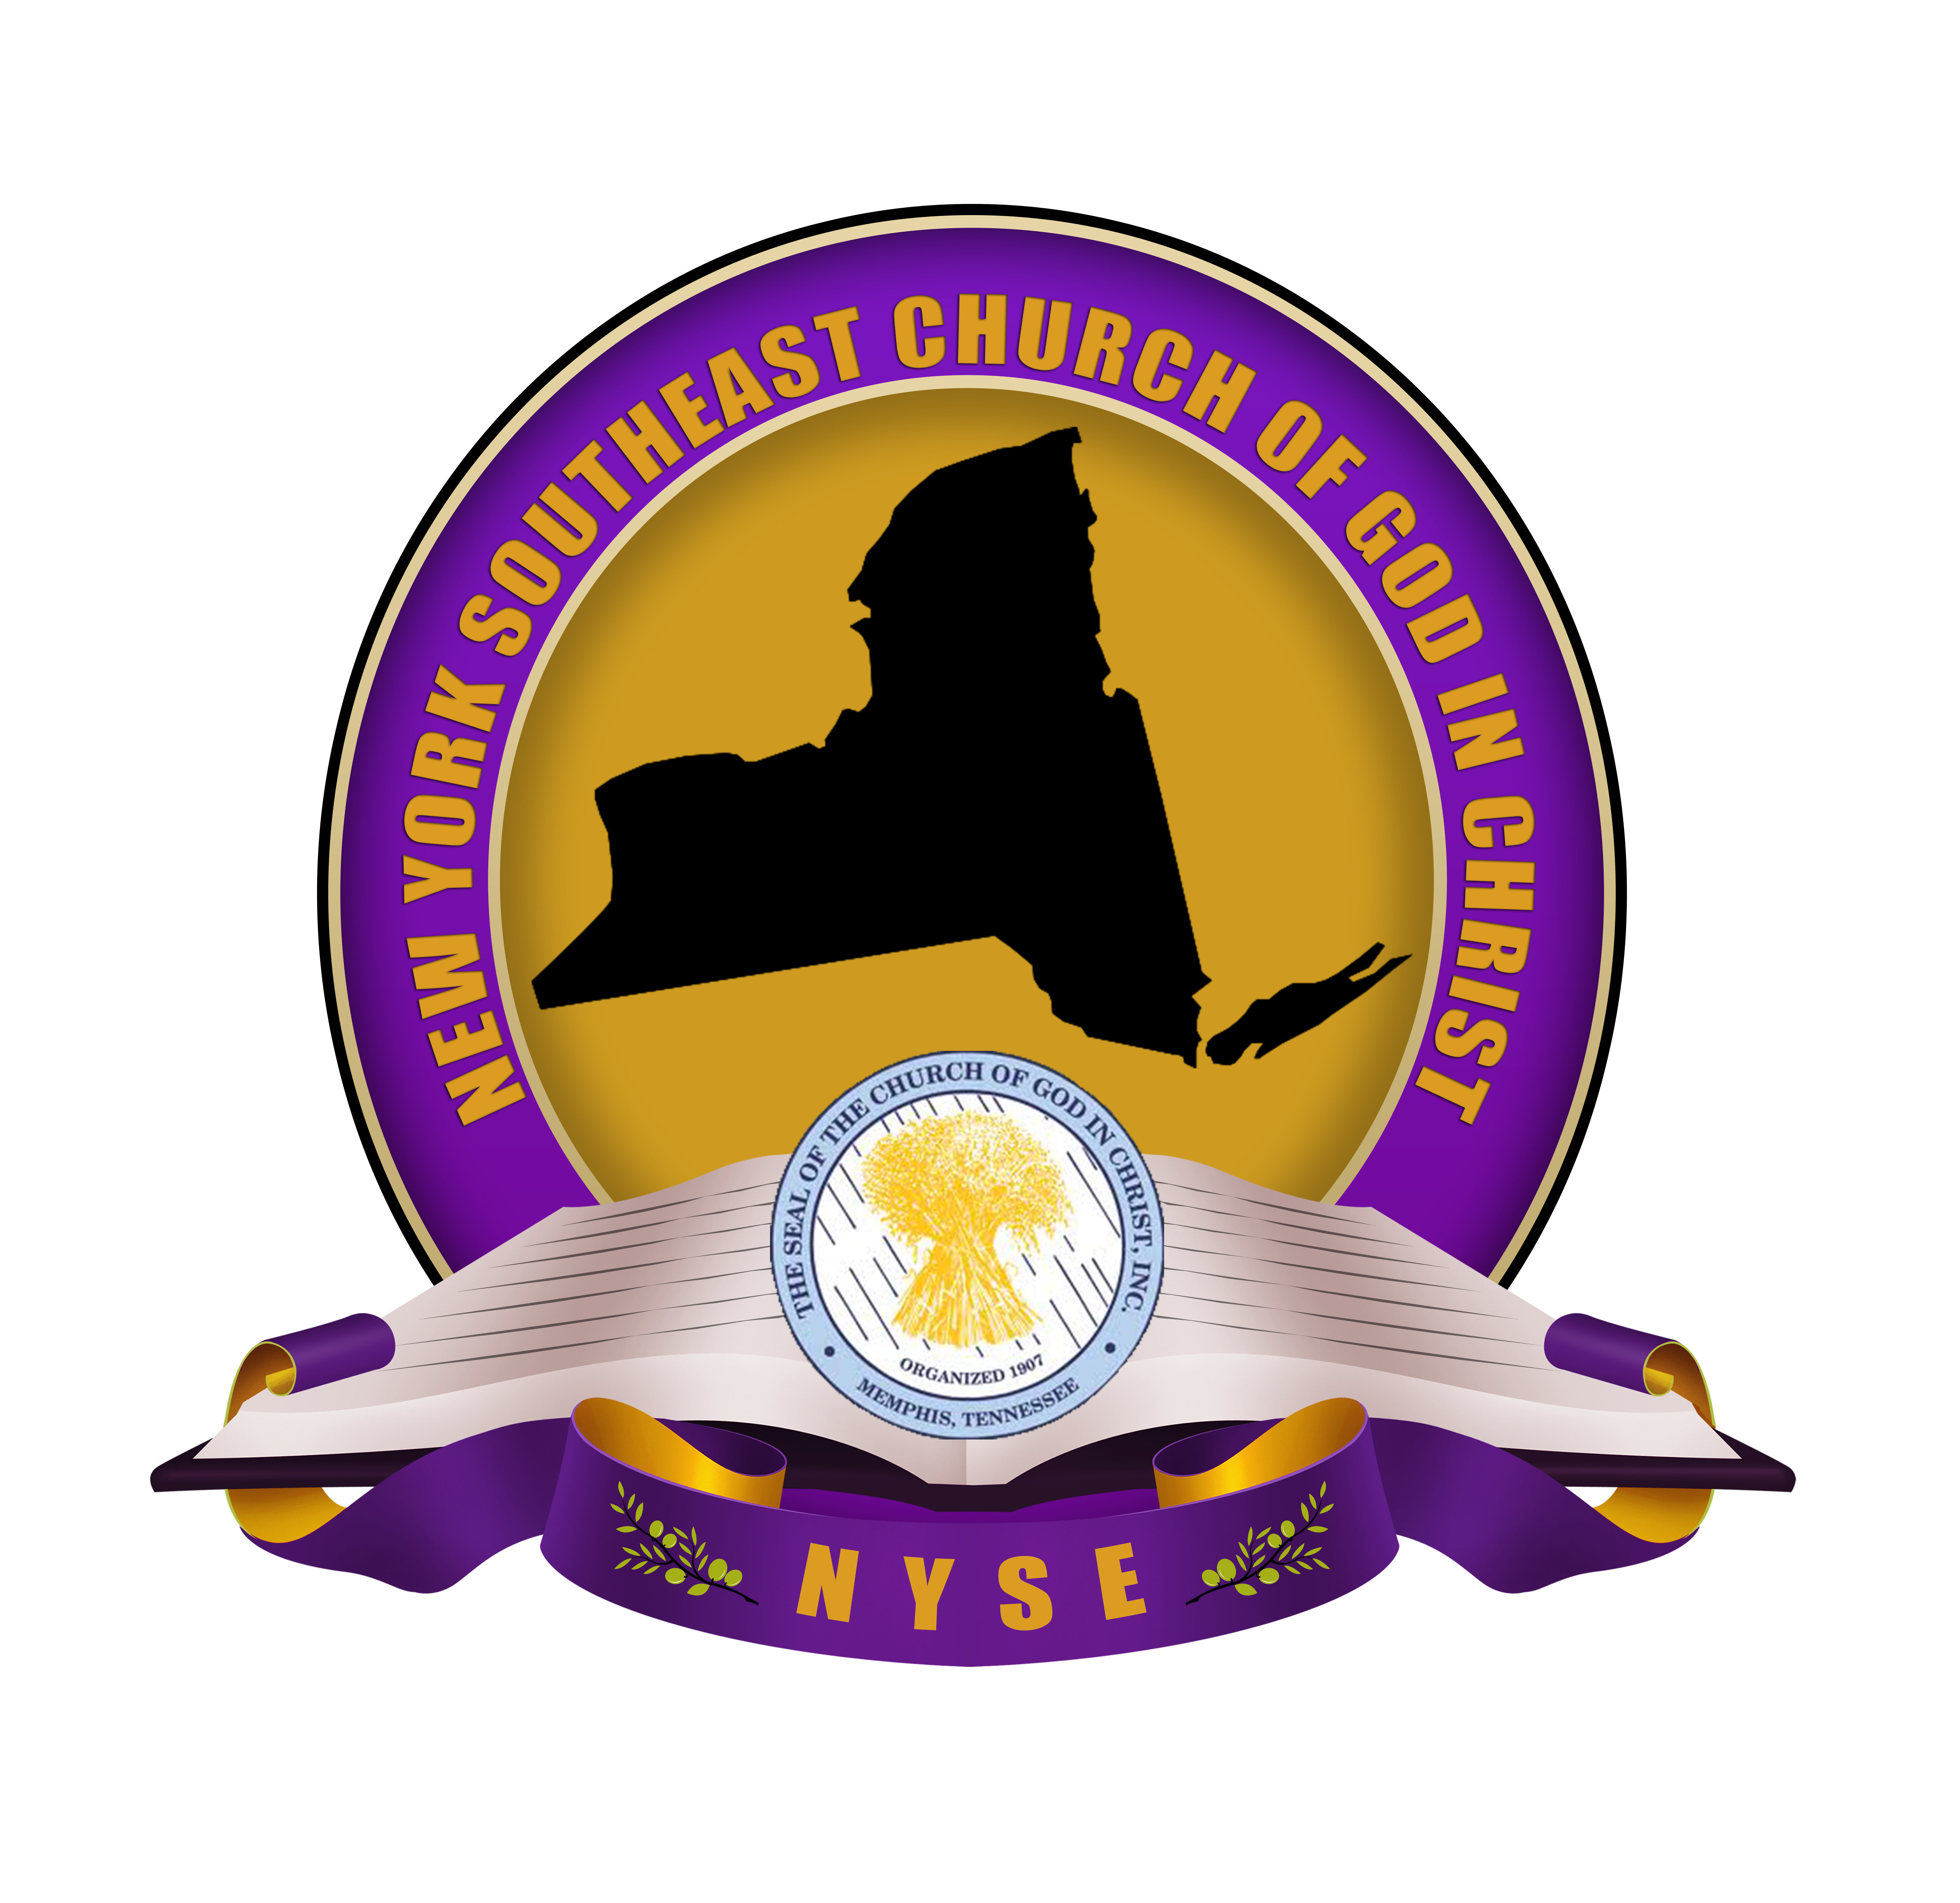
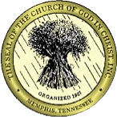
January
Jurisdictional Headquarters
Salvation & Restoration Christian COGIC
1142 Herkimer Street
Brooklyn, New York 11233
(718) 342-8434 ph * (718) 485-3169 fax
“Empowering, Equipping and Engaging Believers for Kingdom Ministry”
COME FELLOWSHIP WITH US AT ONE OF OUR MANY WORSHIP OPPORTUNITIES
Bishop Charles E. Blake
International Presiding Bishop

Bishop Tyrone L. Butler
Jurisdictional Prelate

2016
Sun | Mon | Tue | Wed | Thu | Fri | Sat
 |  |  |  |  | 1 NEW YEAR’S DAY | 2 Jurisdiction Events - Jurisdictional Installation & Communion Service
3 | 4 | 5 | 6 | 7 | 8 | 9
10 | 11 | 12 | 13 | 14 | 15 | 16
17 | 18 MLK Birthday  COGIC Leadership Conf- Albuguerque, NM | 19 COGIC Leadership Conf- Albuguerque, NM | 20 COGIC Leadership Conf- Albuguerque, NM | 21 COGIC Leadership Conf- Albuguerque, NM | 22 | 23 NYSE Women’s Dept Set-up Meeting 10:00 a.m.
24 | 25 | 26 | 27 | 28 | 29 | 30
31

February
Sun | Mon | Tue | Wed | Thu | Fri | Sat
 | 1 | 2 | 3 | 4 | 5 | 6 Jurisdictional Events -Quarterly Empowerment Conference – 11:00 a.m.
7 | 8 NYSEJ Exec Board Bi-Monthly | 9 | 10 | 11 | 12 | 13
14 Valentines Day | 15 Presidents Day | 16 | 17 | 18 | 19 | 20
21 | 22 | 23 | 24 | 25 | 26 | 27
28 | 29

2016
Jurisdictional Headquarters
Salvation & Restoration Christian COGIC
1142 Herkimer Street
Brooklyn, New York 11233
(718) 342-8434 ph * (718) 485-3169 fax
“Empowering, Equipping and Engaging Believers for Kingdom Ministry”
COME FELLOWSHIP WITH US AT ONE OF OUR MANY WORSHIP OPPORTUNITIES
Bishop Charles E. Blake
International Presiding Bishop

Bishop Tyrone L. Butler
Jurisdictional Prelate

March
Sun | Mon | Tue | Wed | Thu | Fri | Sat
 |  | 1 | 2 | 3 | 4 | 5 Jurisdictional Events -
6 | 7 | 8 | 9 | 10 | 11 | 12
13 | 14 | 15 | 16 | 17 | 18 | 19
20 PALM SUNDAY | 21 DISTRICT MEETINGS-Mid Hudson, Supt. Stukes | 22 DISTRICT MEETINGS-Mid Hudson | 23 DISTRICT MEETINGS-Mid Hudson | 24 DISTRICT MEETINGS-Mid Hudson | 25 DISTRICT MEETINGS-Mid Hudson | 26
27 EASTER | 28 | 29 | 30 | 31

2016
Jurisdictional Headquarters
Salvation & Restoration Christian COGIC
1142 Herkimer Street
Brooklyn, New York 11233
(718) 342-8434 ph * (718) 485-3169 fax
“Empowering, Equipping and Engaging Believers for Kingdom Ministry”
COME FELLOWSHIP WITH US AT ONE OF OUR MANY WORSHIP OPPORTUNITIES
Bishop Charles E. Blake
International Presiding Bishop

Bishop Tyrone L. Butler
Jurisdictional Prelate

24th ANNUAL PASTORS & WORKERS CONFERENCE
Brooklyn, New York

April
Sun | Mon | Tue | Wed | Thu | Fri | Sat
 |  |  |  |  | 1 | 2 Jurisdictional Events - Call Meeting and Assembly
3 | 4 COGIC Annual Spring Call Meeting-Memphis,TN | 5 COGIC Annual Spring Call Meeting | 6 COGIC Annual Spring Call Meeting | 7 COGIC Annual Spring Call Meeting | 8 | 9
10 | 11 NYSEJ Exec Board Bi-Monthly | 12 | 13 | 14 | 15 | 16
17 | 18 DISTRICT MEETINGS-Queen Esther, Supt. Borden | 19 DISTRICT MEETINGS-Queen Esther | 20 DISTRICT MEETINGS-Queen Esther | 21 DISTRICT MEETINGS-Queen Esther | 22 DISTRICT MEETINGS-Queen Esther | 23
24 | 25 | 26 | 27  DISTRICT MEETINGS-Mid Hudson, Supt. Stukes | 28  DISTRICT MEETINGS-Mid Hudson | 29  DISTRICT MEETINGS-Mid Hudson | 30

2016
Jurisdictional Headquarters
Salvation & Restoration Christian COGIC
1142 Herkimer Street
Brooklyn, New York 11233
(718) 342-8434 ph * (718) 485-3169 fax
“Empowering, Equipping and Engaging Believers for Kingdom Ministry”
COME FELLOWSHIP WITH US AT ONE OF OUR MANY WORSHIP OPPORTUNITIES
Bishop Charles E. Blake
International Presiding Bishop

Bishop Tyrone L. Butler
Jurisdictional Prelate

May
Sun | Mon | Tue | Wed | Thu | Fri | Sat
1 | 2 | 3 | 4 | 5 | 6 | 7 Jurisdictional Events - Bible School Graduation
8 Mothers Day | 9 NYSEJ Exec Board Bi-Monthly | 10 | 11 | 12 | 13 | 14
15 PENTECOST SUNDAY | 16 | 17 | 18 DISTRICT MEETINGS-Manhattan, Supt. Pressley | 19 DISTRICT MEETINGS-Manhattan | 20 DISTRICT MEETINGS-Manhattan | 21
22 | 23 | 24 | 25 | 26 | 27 | 28
29 | 30 Memorial Day 66th Annual Women’s Convention-Detroit, MI | 31 66th Annual Women’s Convention-Detroit, MI

2016
Jurisdictional Headquarters
Salvation & Restoration Christian COGIC
1142 Herkimer Street
Brooklyn, New York 11233
(718) 342-8434 ph * (718) 485-3169 fax
“Empowering, Equipping and Engaging Believers for Kingdom Ministry”
COME FELLOWSHIP WITH US AT ONE OF OUR MANY WORSHIP OPPORTUNITIES
Bishop Charles E. Blake
International Presiding Bishop

Bishop Tyrone L. Butler
Jurisdictional Prelate

June
Sun | Mon | Tue | Wed | Thu | Fri | Sat
 |  |  | 1 66th Annual Women’s Convention-Detroit, MI | 2 66th Annual Women’s Convention-Detroit, MI | 3 66th Annual Women’s Convention-Detroit, MI | 4 Jurisdictional Events - Quarterly Empowerment Conference
5 | 6 DISTRICT MEETINGS-Liberty, Supt. Griffin | 7 DISTRICT MEETINGS-Liberty | 8 DISTRICT MEETINGS-Liberty | 9 DISTRICT MEETINGS-Liberty | 10 DISTRICT MEETINGS-Liberty | 11
12 | 13 NYSEJ Exec Board Bi-Monthly | 14 | 15 | 16 | 17 | 18
19 Fathers Day | 20 | 21 | 22 | 23 | 24 | 25
26 | 27 | 28 | 29 | 30

2016
Jurisdictional Headquarters
Salvation & Restoration Christian COGIC
1142 Herkimer Street
Brooklyn, New York 11233
(718) 342-8434 ph * (718) 485-3169 fax
“Empowering, Equipping and Engaging Believers for Kingdom Ministry”
COME FELLOWSHIP WITH US AT ONE OF OUR MANY WORSHIP OPPORTUNITIES
Bishop Charles E. Blake
International Presiding Bishop

Bishop Tyrone L. Butler
Jurisdictional Prelate

New York Southeast
A.I.M. (Auxiliaries In Ministry) CONFERENCE
June 15 - 18
Salvation and Restoration COGIC, Brooklyn

July
Sun | Mon | Tue | Wed | Thu | Fri | Sat
 |  |  |  |  | 1 | 2 Jurisdictional Events - CANCELLED
3 | 4 International AIM Convention-Cincinatti, OH | 5 International AIM Convention-Cincinatti, OH | 6 International AIM Convention-Cincinatti, OH | 7 International AIM Convention-Cincinatti, OH | 8 International AIM Convention-Cincinatti, OH | 9
10 | 11 NYSEJ Exec Board Bi-Monthly | 12 | 13 | 14 | 15 | 16
17 | 18 | 19 | 20 | 21 | 22 | 23 NYSE Picnic Day @ FDR State Park – 11:00 a.m
24 | 25 | 26 | 27 | 28 | 29 | 30
31

2016
Jurisdictional Headquarters
Salvation & Restoration Christian COGIC
1142 Herkimer Street
Brooklyn, New York 11233
(718) 342-8434 ph * (718) 485-3169 fax
“Empowering, Equipping and Engaging Believers for Kingdom Ministry”
COME FELLOWSHIP WITH US AT ONE OF OUR MANY WORSHIP OPPORTUNITIES
Bishop Charles E. Blake
International Presiding Bishop

Bishop Tyrone L. Butler
Jurisdictional Prelate

August
Sun | Mon | Tue | Wed | Thu | Fri | Sat
 | 1 | 2 | 3 | 4 | 5 | 6 Jurisdictional Events - World Evangelism Day
7 | 8 NYSEJ Exec Board Bi-Monthly | 9 | 10 | 11 | 12 | 13
14 | 15 | 16 | 17 | 18 | 19 | 20
21 24th Annual Holy Convocation OFFICIAL DAY | 22 | 23 | 24 | 25 | 26 | 27
28 | 29 | 30 | 31

2016
Jurisdictional Headquarters
Salvation & Restoration Christian COGIC
1142 Herkimer Street
Brooklyn, New York 11233
(718) 342-8434 ph * (718) 485-3169 fax
“Empowering, Equipping and Engaging Believers for Kingdom Ministry”
COME FELLOWSHIP WITH US AT ONE OF OUR MANY WORSHIP OPPORTUNITIES
Bishop Charles E. Blake
International Presiding Bishop

Bishop Tyrone L. Butler
Jurisdictional Prelate

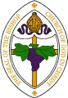
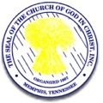
24th ANNUAL HOLY CONVOCATION
Brooklyn, New York

September
2016
Jurisdictional Headquarters
Salvation & Restoration Christian COGIC
1142 Herkimer Street
Brooklyn, New York 11233
(718) 342-8434 ph * (718) 485-3169 fax
“Empowering, Equipping and Engaging Believers for Kingdom Ministry”
COME FELLOWSHIP WITH US AT ONE OF OUR MANY WORSHIP OPPORTUNITIES
Bishop Charles E. Blake
International Presiding Bishop

Bishop Tyrone L. Butler
Jurisdictional Prelate

Sun | Mon | Tue | Wed | Thu | Fri | Sat
 |  |  |  | 1 | 2 | 3 Jurisdictional Events - Quarterly Empowerment Conference
4 Bishop Butler Birthday | 5 | 6 | 7 | 8 | 9 | 10
11 | 12 | 13 | 14 DISTRICT MEETINGS-Acts 2:42, Supt. Jerry Hutton | 15 DISTRICT MEETINGS-Acts 2:42, Supt. Jerry Hutton | 16 DISTRICT MEETINGS-Acts 2:42 | 17
18 | 19 | 20 | 21 | 22 | 23 | 24
25 | 26 | 27 | 28 | 29 | 30

New York Southeast
23rd ANNUAL WOMEN’S CONVENTION
September 28 – 30, 2016

October
Sun | Mon | Tue | Wed | Thu | Fri | Sat
 |  |  |  |  |  | 1 Jurisdictional Events -
2 | 3 | 4 | 5 | 6 | 7 | 8
9 | 10 Columbus Day NYSEJ Exec Board Bi-Monthly | 11 | 12 | 13 | 14 | 15
16 | 17 | 18 | 19 | 20 | 21 | 22
23 | 24 | 25 | 26 | 27 | 28 | 29 NY Southeast Annual Judah Jam
30 | 31

2016
Jurisdictional Headquarters
Salvation & Restoration Christian COGIC
1142 Herkimer Street
Brooklyn, New York 11233
(718) 342-8434 ph * (718) 485-3169 fax
“Empowering, Equipping and Engaging Believers for Kingdom Ministry”
COME FELLOWSHIP WITH US AT ONE OF OUR MANY WORSHIP OPPORTUNITIES
Bishop Charles E. Blake
International Presiding Bishop

Bishop Tyrone L. Butler
Jurisdictional Prelate

November
2016
Jurisdictional Headquarters
Salvation & Restoration Christian COGIC
1142 Herkimer Street
Brooklyn, New York 11233
(718) 342-8434 ph * (718) 485-3169 fax
“Empowering, Equipping and Engaging Believers for Kingdom Ministry”
COME FELLOWSHIP WITH US AT ONE OF OUR MANY WORSHIP OPPORTUNITIES
Bishop Charles E. Blake
International Presiding Bishop

Bishop Tyrone L. Butler
Jurisdictional Prelate

Sun | Mon | Tue | Wed | Thu | Fri | Sat
 |  | 1 | 2 | 3 | 4 | 5
6 | 7 109TH Annual Holy Convocation-St Louis, MO | 8 109TH Annual Holy Convocation-St Louis, MO | 9 109TH Annual Holy Convocation-St Louis, MO | 10 109TH Annual Holy Convocation-St Louis, MO | 11 Veterans Day | 12 109TH Annual Holy Convocation-St Louis, MO
13 109TH Annual Holy Convocation-St Louis, MO OFFICIAL DAY | 14 | 15 | 16 | 17 | 18 | 19
20 | 21 | 22 | 23 | 24 Thanksgiving Day | 25 | 26 NY Southeast MY Fall Holiday Prayze Service
27 | 28 | 29 | 30

December
2016
Jurisdictional Headquarters
Salvation & Restoration Christian COGIC
1142 Herkimer Street
Brooklyn, New York 11233
(718) 342-8434 ph * (718) 485-3169 fax
“Empowering, Equipping and Engaging Believers for Kingdom Ministry”
COME FELLOWSHIP WITH US AT ONE OF OUR MANY WORSHIP OPPORTUNITIES
Bishop Charles E. Blake
International Presiding Bishop

Bishop Tyrone L. Butler
Jurisdictional Prelate

Sun | Mon | Tue | Wed | Thu | Fri | Sat
 |  |  |  | 1 | 2 Jurisdictional Events - Year End Retreat & Leaders Summit | 3 Jurisdictional Events - Year End Retreat & Leaders Summit
4 | 5 | 6 | 7 | 8 | 9 | 10
11 | 12 NYSEJ Exec Board Bi-Monthly | 13 | 14 | 15 | 16 | 17
18 | 19 | 20 | 21 | 22 | 23 | 24 Christmas Eve
25 Christmas Day | 26 | 27 | 28 | 29 | 30 | 31 New Year’s Eve  Watch Night

